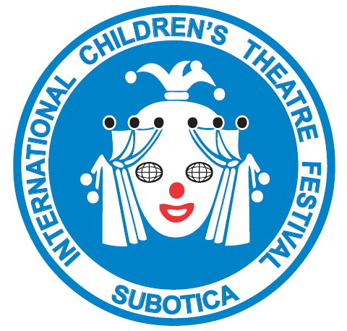

30th International Festival of Children’s Theatres

Subotica, Serbia: 17 - 22 September 2023

APPLICATION FORM
Name of the theatre
Address, city, country
Web site
Phone-Fax-E-mail
Contact person
Performance title
Author
Director
Stage design
Puppet design
Music (author / composer)
Cast
Form: puppetry, drama…
Language
Age of the audience
Stage - dimensions | width: |  | depth: |  | height:
Sound requirements
Lighting requirements
Performance duration
Stage set-up time
Stage dismantling time
Number of persons | actors: | technicians: |  | others: |  | total:
How does the group travel
When does the group arrive
When does the group depart

PLACE: _____________ DIRECTOR
DATE: ______________ ______________

